Level Editor Instructions

By Oliver Blackwell (s1802385)

# Using the Toolbar:

## Selecting a Tool:

As shown in ‘Figure 1’, there is the Pen Tool and Erase Tool. If using the Pen Tool, this will draw the Tile into the grid square, and if using the Erase Tool, it will remove the Tile from the grid and will turn it back into a white box.

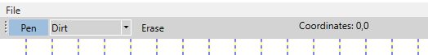

Figure

## Selecting a Tile:

As shown in ‘Figure 2’, use the drop-down list and choose the tile which you would like to use.

For now, there are only four options which can be used ‘Dirt’, ‘Sand’, ‘Grass’ & ‘Water’.

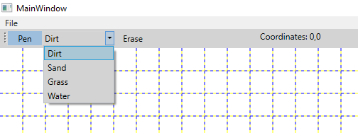

Figure

## Checking Co-ordinates:

As shown within ‘Figure 1’ & ‘Figure 2’, the Co-ordinates text is on the right-hand side of the toolbar. This gets updated with every ‘Pen’ click which is made.

# File:

## Options:

As shown in ‘Figure 3’, there are 4 options to choose from in the File button.

New – This button creates a new file and wipes all the previous work from the screen. Make sure you save if you don’t want this work to be lost.

Open – This button will allow you to open a previous document. The document will have to be a ‘JSON’ file created from this editor.

Save – This button allows you to save your work as a ‘JSON’ file which can be re-opened and re-edited.

Exit – This button closes the application. Alike the New button, make sure your work is saved before Exiting the Level Editor.

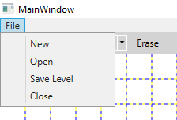

Figure